

Employee Info Starter Kit (v2.2.0)
VSTS 2008 Edition - Whitepaper
Mohammad Ashraful Alam
Microsoft MVP
17-Apr-09
http://code.msdn.microsoft.com/eisk

Table of Contents
5 Minutes Quick Start 6
Summery 6
Walkthrough 6
Minute 1: Download the starter kit 6
Minute 1: Open the solution file, located at the location below: 6
Minute 2: Press F-5 to start the employee info starter kit web site. 6
Minute 3: Test database connection string 6
Minute 4: Install database automatically 8
Minute 5: The default page 9
Overview 11
Summery 11
System Requirements 11
- Visual Studio 2008 (or higher) 11
- Sql Server 2005 or higher 11
User End Functional Specification 11
[C]reating a new employee record 11
[R]ead existing employee record 11
[U]pdate an existing employee record 11
[D]elete existing employee records 12
Architectural Overview 12
Technology Utilized 12
Programming Languages/Scripts 12
.NET Framework Components 12
Visual Studio Features 12
Sql Server Features 13
Validation 13
Installation and Configuration 14
Visual Studio Solution Overview 14
…\Web: 14
Eisk.Library 14
Eisk.Tests 14
Install and Configure the Database 14
Installing the database 14
Configure the Database (Manually) 18
Running the Web Site 19
Running the Test Project 20
Architecture 22
Architectural Overview 22
Implementation 23
Database 23
Implementation Artifact 23
Table 23
Stored Procedure 23
Data Access Layer 24
Entity Based Data Access Layer 25
Command Wrapper Data Access Layer 26
Data Utility Classes 27
Utility Classes 28
Cache Layer 29
User Interface Layer 30
Themes 30
Master Page 30
User Controls 31
Listing Page 31
Detail Page 32
Role Based Security 33
Testing 34
Testing Overview 34
Configuration 34
Configuration Testing 35
Project Configuration 35
Database Configuration 35
Production Tests 36
Data Access Layer Testing 36
Implementation Artifact 36
Lazy Data Access Layer Testing 36
Implementation Artifact 36
Database Unit Testing 36
Implementation Artifact 36
Acceptance Testing for CRUD 36
Implementation Artifact 36
Load Testing 36
Implementation Artifact 36
Helper Classes 36
Implementation Artifact 37
Automated Setup 37
Database Schema and Data Generator 37
COM+ Helper 37
Factory Method 37
Web Request Helper 37
History 38
License 38
Disclaimer 38
Feedback 38
About the Author 38

5 Minutes Quick Start

Summery
This is a starter kit, which includes very simple user requirements, where we can create, read, update and delete (CRUD) the employee info of a company.

Walkthrough

Minute 1: Download the starter kit
Download the starter kit from here.

Minute 1: Open the solution file, located at the location below:
<Extraction directory>\solution
Click on “e-i-s-k-2008.sln”file if you wish to open the solution in Visual Studio 2008, or click on “e-i-s-k-2005.sln”file if you wish to open the solution in Visual Studio 2005

Minute 2: Press F-5 to start the employee info starter kit web site.
Yeah… just press F-5!

Minute 3: Test database connection string
If the default database connection string doesn’t work for you, then while you first run the web site, a database installation page will appear as shown below, where you need to provide database connection info.
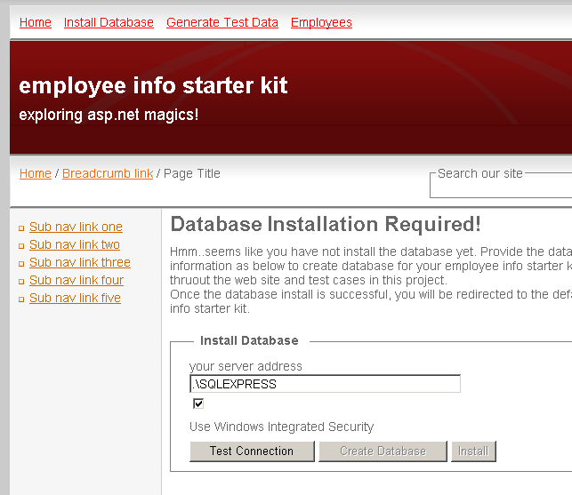
Once you provide the database server connection info (server address, authentication info etc) click on the “Test Connection” button placed at the bottom, as shown below.
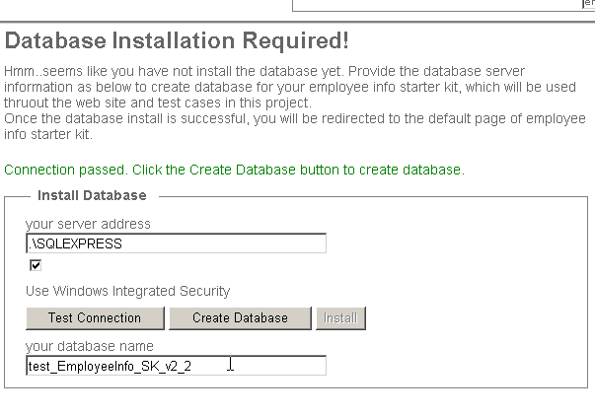

Minute 4: Install database automatically
Once the connection test is successful, click on the create database and install button, one by one to install database schema and data to the corresponding database.
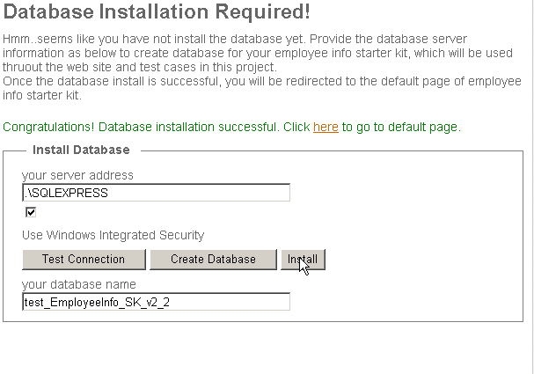
After successful database installation the application will update the underlying configuration files (i.e. web.config file of the web site, app.config file for the test site) accordingly.

Minute 5: The default page
Once all goes fine, you can click on the link provided to be redirected to the default page of employee info starter kit, which shows all of the employee info in an ASP.NET GridView. You can perform CRUD (Create, Read, Update and Delete) over the employee entity, using the corresponding button, which are self explanatory.
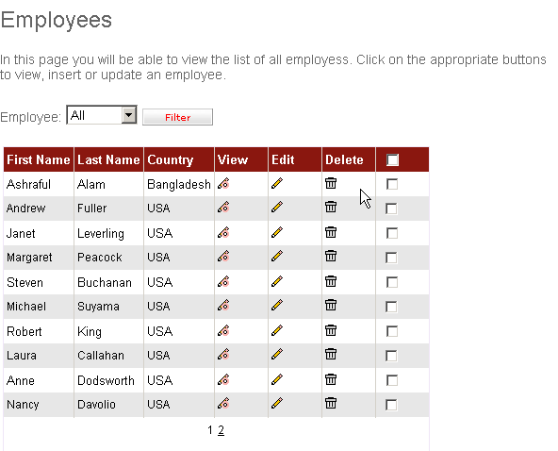

Overview

Summery
This is a starter kit, which includes very simple user requirements, where we can create, read, update and delete (CRUD) the employee info of a company.
The primary purpose of this starter kit is, to provide a solid guideline with respect to building enterprise level projects, by utilizing asp.net 2.0 and Sql server 2005 features, as well as latest best coding practices.
The starter kit includes several cases where we can perform multi-table joining and/or write operations. Combining high performance and security features this starter kit shows how we can solve in real world problems and challenges, from a wide range of view point.

System Requirements

- Visual Studio 2008 (or higher)
There are three Visual Studio projects included in the current edition of Employee Info Starter Kit. If you have only Visual Studio 2008 (higher) installed at your machine, you should be able to run and utilize 2 main projects (the web site and the main class library).
If you have the full edition of Visual Studio Team System 2008 (or higher), you are good to go to run all these 3 projects. If not you need to have the corresponding related editions of Visual Studio 2008 Team System (or higher) installed at your machine.
Visual Studio Team System 2008 (or higher) Developer Edition: to run the code analysis tool
Visual Studio Team System 2008 (or higher) Test Edition: to run the test project included with this starter kit

- Sql Server 2005 or higher
Any edition of Sql Server 2005 or higher, such as Express, Enterprise, Developer edition.

User End Functional Specification
The user end functionalities of this starter kit are pretty simple and straight forward that are focused in to perform CRUD operation on employee records as described below.

[C]reating a new employee record
The users should be able to create new employee record, one at a single time.

[R]ead existing employee record
The users should be able to view the employee records in list style, where maximum 10 records can be visible per page and the list can be filtered out based on their supervisors. The user should also be able to view employee records with details, once at a single time and can print it in a printable format.

[U]pdate an existing employee record
The users should be able to update an existing employee record, one at a single time.

[D]elete existing employee records
The users should be able to delete single or multiple employees at a time while viewing employee records in list style.

Architectural Overview
- Simple 2 layer architecture (user interface and data access layer) with 1 optional cache layer
- ASP.NET Web Form Based User Interface
- Custom Entity Data Container implemented (with primitive C# types for data fields)
- Static type CRUD methods embedded with Data container, implemented in C#
- Sql Server Stored Procedure to perform actual CRUD operation
- Automated testing infrastructure to ensure quality

Technology Utilized

Programming Languages/Scripts
- Browser side: JavaScript
- Web server side: C# 2.0
- Database server side: T-SQL

.NET Framework Components
- .net 2.0 generic type
- .net 2.0 nullable type
- asp.net 2.0 object data source
- asp.net 2.0 grid view
- asp.net 2.0 form view
- asp.net 2.0 skin
- asp.net 2.0 theme
- asp.net 2.0 master (nested)

Visual Studio Features
- Visual Studio Code Analysis
- Visual Studio Unit Test
- Visual Studio Database Unit Test
- Visual Studio Web Test
- Visual Studio Load Test

Sql Server Features
- Sql server 2005 Stored Procedure
- Sql server 2005 Xml type
- Sql server 2005 Paging support

Validation
- XHTML 1.1, CSS level 2.1, WCAG 1, ABS 508
- MS Guideline

Installation and Configuration

Visual Studio Solution Overview
Once you extract the downloaded file, and open the solution (located at <Extraction directory>\solution folder) accordingly, you will find there are three Visual Studio projects included in the current edition of Employee Info Starter Kit, as described below:

…\Web:
Contains the basic web site, that contains all user interface related contents, such as web forms (.aspx files), user controls (.ascx files), master pages (.master files), style sheets (.css files), images etc along with user interface related logics implemented in C# and located at code behind pages.

Implementation Artifact
The corresponding contents are located at the following location:
<Extraction directory>\web

Eisk.Library
Contains the core logics, implemented in C#, which includes database layer, caching and several utility functionalities.

Implementation Artifact
The corresponding contents are located at the following location:
<Extraction directory>\library\Eisk.Library

Eisk.Tests
Contains all types of automated tests for this starter kit, such as Web Test, Load Test, Unit Test and Database Unit Test. To open the project successfully you will require Visual Studio Team System Test Edition installed.

Implementation Artifact
The corresponding contents are located at the following location:
<Extraction directory>\tests\Eisk.Tests

Install and Configure the Database

Installing the database
There are two ways to install the corresponding database for Employee Info Starter Kit. You can choose any one of these solution based on your need. However while using any one of these solution, make sure you use the appropriate Sql Server log-in info with having proper administrative privilege to run these scripts.

Using Default Installation Web User Interface

If the default database connection string doesn’t work for you, then while you first run the web site, a database installation page will appear as shown below, where you need to provide database connection info.
Once you provide the database server connection info (server address, authentication info etc) click on the “Test Connection” button placed at the bottom, as shown below.
Once the connection test is successful, click on the create database and install button, one by one to install database schema and data to the corresponding database.
After successful database installation the application will update the underlying configuration files (i.e. web.config file of the web site, app.config file for the test site) accordingly.

Using Sql Sever 2005 (or higher) Management Studio
Open the Sql Server Management Studio, log-in to your database server.
You need to create the database first! You can do that by Sql Server Management Studio user interface or by running the database creation script.
To create the database by Sql Server Management Studio user interface, right click on the database node on object explorer window, select the “Create Database” option and provide your desired name of the database (for instance test_EmployeeInfo_SK_v2_2).
To create the database using script, open the database creation script from the following location, by using File -> Open menu of Sql Server Management Studio.
<Extraction directory>\Database\primary-scripts\CreateDatabase.sql
Now you need to generate the database schema (table, stored procedure etc) on the database you just created (for instance test_EmployeeInfo_SK_v2_2). Open the schema creation script from the following location, by using File -> Open menu of Sql Server Management Studio.
<Extraction directory>\Database\primary-scripts\CreateSchema.sql
Select the database that you created from the database dropdown menu as shown below.
Hit F5! Your schema should be created!
Now the last step! You need to install some sample data. Open the schema creation script from the following location, by using File -> Open menu of Sql Server Management Studio.
<Extraction directory>\Database\primary-scripts\CreateSetupData.sql
Select the database that you created from the database dropdown menu as shown earlier. Hit F5! Your sample data should be generated!

Configure the Database (Manually)
Employee Info starter kit requires the corresponding database schema installed to a particular database. For this reason the required configuration setting needs to be adjusted properly. These configuration values will be adjusted automatically when you first run the web site and provide required Sql Server access info, as described in the “Using Default Installation Web User Interface” section. Alternatively you can install and configure the database settings manually.
The database related configuration needs to be adjusted in both web and test project to run them successfully, as mentioned below:

…\Web
A connection string is defined in the “web.config” file of the web site, located in the following location:
<Extraction directory>\web\web.config
In the web.config file, configuration- connectionStrings section, you will find a key named “EmployeeDB” as shown below.

Eisk.Tests
The database connection string for test project also needs to be configured, which can also be updated either automatically or manually, located in the following location.
<Extraction directory>\tests\app.config
In the app.config file, configuration- connectionStrings section, you will find a key named “EmployeeDB” as shown below.
To run the database unit testing successfully, you will also need to configure the database connection strings, under configuration-DatabaseUnitTesting section, as shown below:

Running the Web Site
Running the web site using Visual Studio is pretty simple and straight forward. Open the solution file located at the following location, by just clicking it.
<Extraction directory>\solution
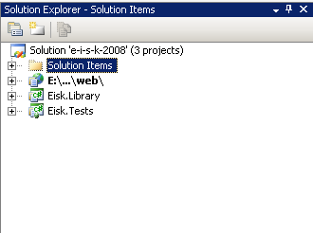
Once it opens successfully, hit F-5!
When you first run the web site, a database installation page will, there you need to provide database connection info. After successful database installation the application will update the underlying configuration files (i.e. web.config file of the web site, app.config file for the test site) accordingly. Once all goes fine, a default link will to provide to you to be redirected to the default page of employee info starter kit, which shows all of the employee info in an ASP.NET GridView.

Running the Test Project
Similar like the Web site, running the test project is also very simple and straight forward. There are two basic type of the testing in the project.
The first one is the “Configuration Tests” which is a group of unit tests that allows you to test if all configuration settings (for instance database connection, web link, email functionality etc) are configured properly. The second type of the “Product Tests” which contains a group of tests related to application logic.
To run the tests properly, first open the Solution Items/e-i-s-k-2008.vsmdi file from the solution explorer as shown below:
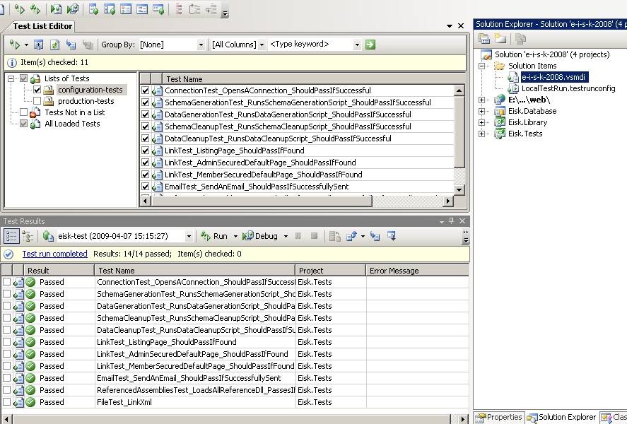
Select the “configuration tests” item from the “Test List Windows” and click on the “Run Checked Tests” command from the upper left corner of the “Test List Window”. The “Test Results” window as shown in the above picture will show the result of all configuration tests. You can do the same for the “production-tests” as listed in the “Test List Editor”.

Architecture

Architectural Overview
- Simple 2 layer architecture (user interface and data access layer) with 1 optional cache layer
- ASP.NET Web Form Based User Interface
- Custom Entity Data Container implemented (with primitive C# types for data fields)
- Static type CRUD methods embedded with Data container, implemented in C#
- Sql Server Stored Procedure to perform actual CRUD operation
- Automated testing infrastructure to ensure quality

Implementation

Database
Database related objects (like tables, stored procedure etc) are one of the most primary artifacts of a data driven application. In this starter kit we have considered table and stored procedure components in Sql Server 2005 or higher.

Implementation Artifact
The entire database related implementation artifacts can be found in the location as provided below, where you will be able to get all Sql scripts in this regard:
<Extraction directory>\database\primary-scripts\

Table
There is only one table in this starter kit to make it simple. However you will be able to get idea in real world data and schema with this single entity, as it contains verity of data types as data fields, along with foreign key relationship within itself. The image below shows the table structure.
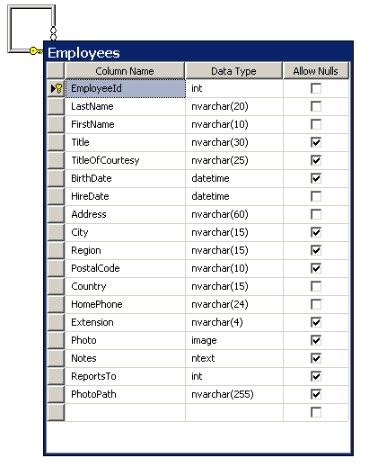

Stored Procedure
There are different types of the stored procedure provided in this starter kit with respect to database CRUD operations, which are provided as below:
- Employees_CreateNewEmployee: creates a new employee and returns the newly generated primary key of the “just created” employee. In this stored procedure we have used the SCOPE_IDENTITY () function which is a best practice which returning newly generated primary key.
- Employees_UpdateEmployee: Updates an existing employee
- Employees_DeleteEmployee: deletes a single employee based on primary key
- Employees_DeleteEmployees: deletes a set of records, based on the passed parameter of list of Id's as xml data. In this stored procedure we have used the xml data type feature available from Sql Server 2005 version, which allows us to pass array like data. Performing data operation over a batch of records is a good practice in terms of application performance (reduces database roundtrip).
- Employees_GetEmployeeByEmployeeId : get by primary key
- Employees_GetEmployeesByReportsTo : get by foreign key
- Employees_GetEmployeesByReportsTo_Paged: get by foreign key as paged result. Paging is one of the most important parts while dealing with large set of data to be shown in ASP.NET controls, like GridView. This stored procedure uses extensive use of RowIndex keyword available from Sql Server 2005 to handle data in paged fashion efficiently. This procedure is being utilized with ASP.NET ObjectDataSource control’s paging functionality.
- Employees_GetEmployeesByReportsTo_Paged_Count: get by foreign key as count method. ASP.NET ObjectDataSource control’s paging functionality also requires a count method, which will contains the number of total records to be used to form the paging functionality.
- Employees_GetAllEmployees : get all records for that entity
- Employees_GetAllEmployees_Paged : get all records as paged result
- Employees_GetAllEmployees_Paged_Count : get all records as count method

Data Access Layer
The data access layer in the one of the most important layer in the application architecture that encapsulates the data access logic in the system. Typically it contains the C# classes, along with corresponding methods that communicates with underlying stored procedures that performs the actual data operation.
Common Crud operations in an application architecture commonly handled by code generators to improve productivity in implementation level. In this case it is useful to isolate the common and custom Crud operations in to a separate area, which will allow you to maintain generated code and non-generated code easily. However whether you should isolate the generated code or use generated code at all totally depends on your application requirements and architecture. In this starter kit, we have isolated data access logic into two areas, as mentioned below:
- Entity Based Data Access Layer and
- Command Wrapper Data Access Layer.

Entity Based Data Access Layer
In this starter kit, we have only one entity, named “Employee” for which we have a database table named “Employees”. The entity based data access layer for this entity contains all of the required and common data access logics that can be typically generated using a code generator.
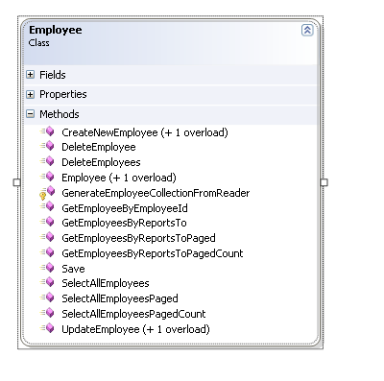

Implementation Artifacts
<Extraction directory>\library\entity\Employee.cs

Overview
- .NET primitive type for data property fields
- Create and Update Method with primitive type parameters for Object Data Source Support
- Design time support for Object Data Source
- Works for only auto-generated primary key
- .Net 2.0 Generic Collection Support
- Isolation for Stored Procedure Name Constants
- XML Comments (useful for nDoc utility)
- Validation for method parameters
- Null values can be saved to database as NULL, by utilizing .NET 2.0 nullable type.

CRUD Methods

Create Methods
* Static method with data fields as method parameter
* Static method with business entity as method parameter
* Instance method, without any parameter

Update Methods
* Static method with data fields as method parameter
* Static method with business entity as method parameter
* Instance method, without any parameter

Get By Primary Key Method
* Method that gets a single record

Get By Foreign Key Method
* Method that returns a collection of records based on the foreign key

Get By Foreign Key - Paged
* Method that returns paged result for the provided foreign key
* Count method being used when using paging method

Get All
* Gets all of the records for the corresponding entity

Get All Paged (Using Sql Server 2005 Paging Support)
* Method that returns paged result for the provided foreign key
* Count method being used when using paging method

Delete By Id
* Deletes a record using the primary key

Batch Delete (Using Sql Server 2005 Xml Type)
* Deletes a set of records, based on the passed parameter of list of Id's as xml data

Command Wrapper Data Access Layer
The Command Wrapper Data Access Layer contains a verity of ways to perform custom Crud operation efficiently. However, please note that, Command Wrapper code samples have provided only for demonstration purpose in this starter kit and not been used by user interface level.
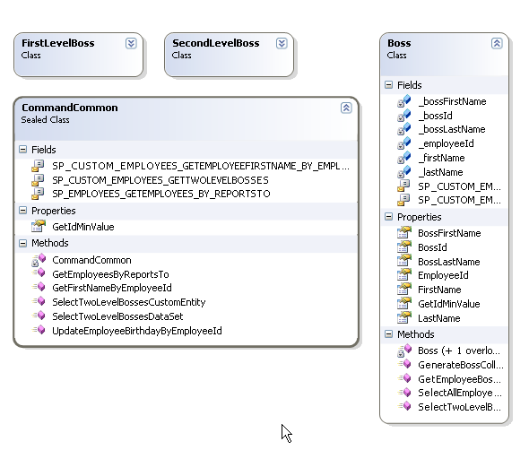

Implementation Artifact
<Extraction directory>\library\command

Operations
- Scalar Value: illustrates how to retrieve scalar (single value) data from database.
- Custom Entity Single Record: illustrates how to retrieve a single record from database and populate it to a custom entity written in C#.
- Custom Entity Tabular: illustrates how to retrieve a collection of data from database and populate it to a single collection of a custom entity written in C#
- Custom Entity Tabular Collection: illustrates how to retrieve a collection of data from database and populate it to a set of collection of a custom entity written in C#
- Generic Data Table: illustrates how to retrieve a collection of data from database and populate it to a .NET generic DataTable instance.
- Generic DataSet: illustrates how to retrieve a collection of data from database and populate it to a .NET generic DataSet instance.
- Write Return Success: Shows how to perform a database write operation and return the success result.

Data Utility Classes
Data utility classes contains simple utility methods that are helpful to reduce the common data access codes and can be used regardless of number of entities in the system architecture.
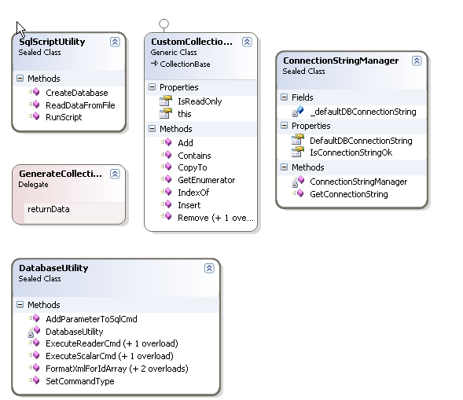

Implementation Artifact
<Extraction directory>\library\data-utils

Utility Classes
Utility classes are the general utility classes that are not relevant to data access logic, but useful while performing application logics (for instance sending email etc).
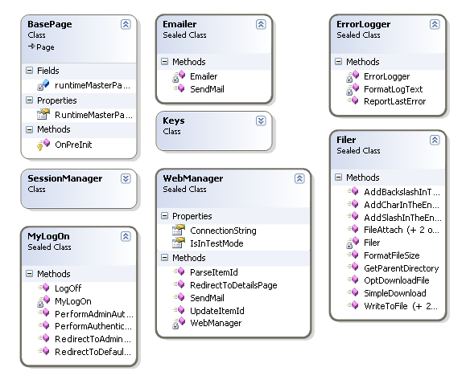

Implementation Artifact
<Extraction directory>\library\app-utils

Cache Layer
Caching is an excellent way to improve application performance, specially the data that are semi-static (i.e. not frequently updated). You can gradually increase the site performance by just putting the corresponding cache layers of the data access/business logic layer. In this starter kit, the cache layer has been implemented as a proxy class of the Entity Based Data Access Layer (i.e. <Extraction directory>\library\entity\Employee.cs) which can be easily replaced between User Interface Layer and Data Access Layer, which less amount of code modification. The cache layer that has been provided in this starter kit contains additional methods that encapsulates cache mechanism which enables the update the cache automatically when there is any update in the underlying entity (however off course those updates needs to be performed via this cache layer).
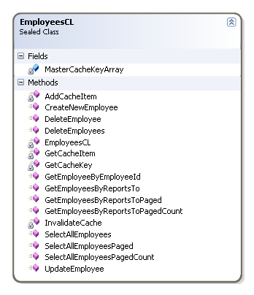

Implementation Artifact
<Extraction directory>\library\cl\EmployeeCL.cs

User Interface Layer
The user interface layer is the layer that has been placed on top of all layers (i.e. business logic, data access, cache layer etc). It contains all server side contents (i.e. user controls, master pages, web forms etc) along with their corresponding code behind classes.

Themes
Using ASP.NET 2.0 Theme feature we can also move to-and-fro between different available themes/design easily. In this starter kit we have two themes, named “brown” and “blue”.

Implementation Artifact
<Extraction directory>\web\App_Themes

Master Page
ASP.NET 2.0 master pages enables us to manage common site regions (such as header, footer, menu etc) easily.
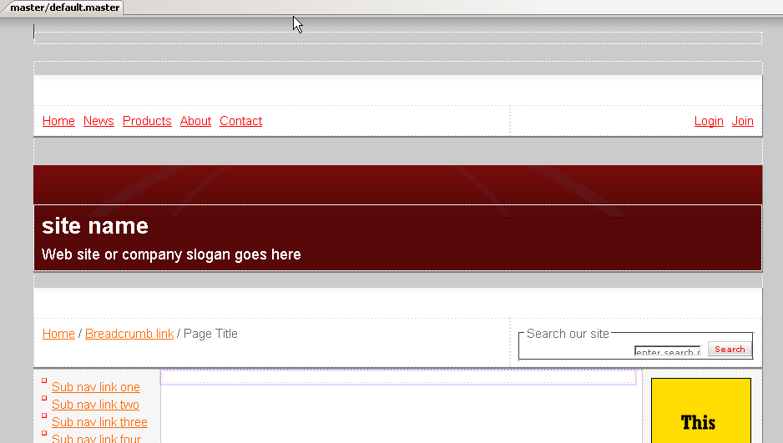

Implementation Artifact
<Extraction directory>\web\master

User Controls
ASP.NET user control is a simple mechanism to utilize common page components that are being used repetitively. Here we have two user controls, one is for Ad banner and another one is for menu.
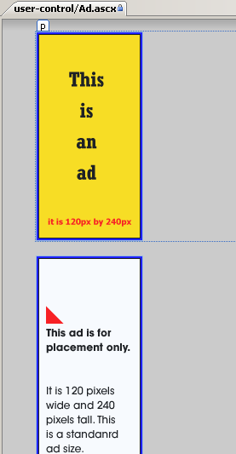

Implementation Artifact
<Extraction directory>\web\user-control

Listing Page
The listing page contains the server side contents and corresponding code behind logic to populate a GridView instance showing list of employees in pages fashion, enabling end users to delete, filter, or move to the details page to see details, create a new employee or modify the record of an existing employee.
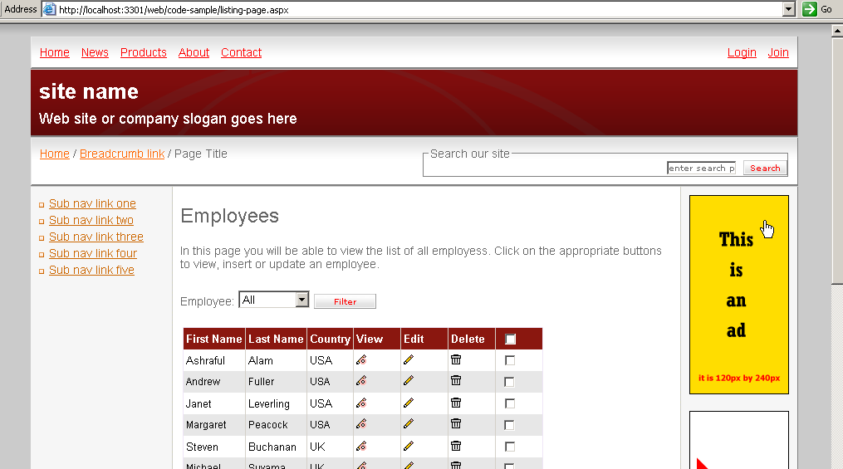

Implementation Artifact
<Extraction directory>\web\code-sample\listing-page.aspx

Detail Page
The details page enables the end users to create a new employee, modify an existing employee and/or to see the details of the employee, for which the user needs to be redirected from the listing page by clicking the corresponding buttons.
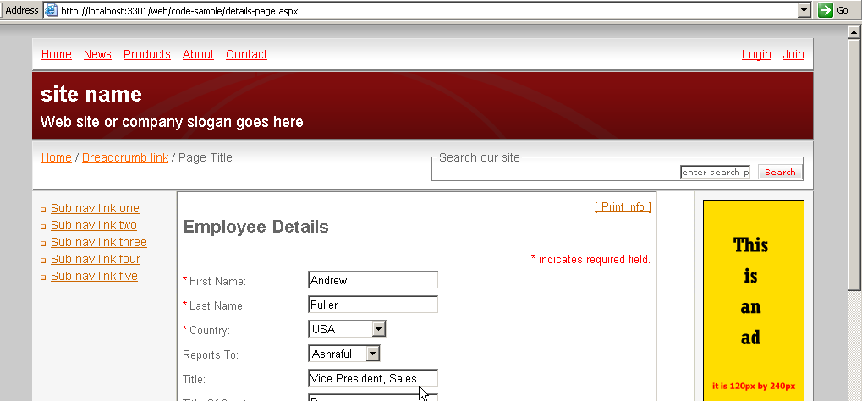

Implementation Artifact
<Extraction directory>\web\code-sample\details-page.aspx

Role Based Security
Role based security is one of the most commonly required functionalities now a days. ASP.NET provides extremely simple and easy framework to perform role based authentication.
For that purpose the corresponding folders/pages where the role based security needs to be implemented needs to be configured in web.config, as below:
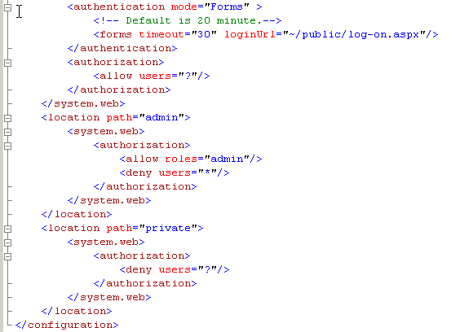
Then the log-in page and the global.asax page will contain the simple codes to maintain the role based security logic.

Implementation Artifact
- <Extraction directory>\web\web.config
- <Extraction directory>\public\log-on.aspx
- <Extraction directory>\web\global.asax

Testing

Testing Overview
The test project included with this starter kit contains a verity of tests that are available in VSTS 2008, such as Web Test, Unit Test, Load Test, Database Unit Test etc.

Implementation Artifact
<Extraction directory>\tests

Configuration
To run all of the tests available in the test project configuration data needs to be adjusted accordingly, located in the Links.xml file of the project.

Implementation Artifact
<Extraction directory>\App_Data\Links.xml
<Extraction directory>\app.config

Website Configuration
In the links.xml there is a section named “links” which contains the links of asp.net pages that are used in the Web Test and Unit Tests.
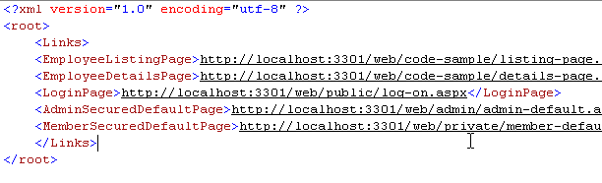

Database Configuration
In the connectionStrings section of app.config file you will find a connection string key, named “EmployeeDB” which is the database connection string used by the data access layer.
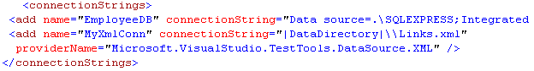
The DatabaseUnitTesting section contains the database connection strings used by the Database Unit Test included in this test project.
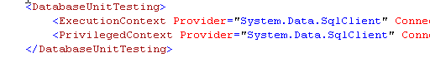

Configuration Testing
The best and easy way to check if all the configuration settings are adjusted properly is to run the configuration tests (which are basically a set of C# Unit Tests).

Implementation Artifact
<Extraction directory>\solution\e-i-s-k-2008.vsmdi
To run the configuration tests properly, first open the Solution Items/e-i-s-k-2008.vsmdi file from the solution explorer as shown below:
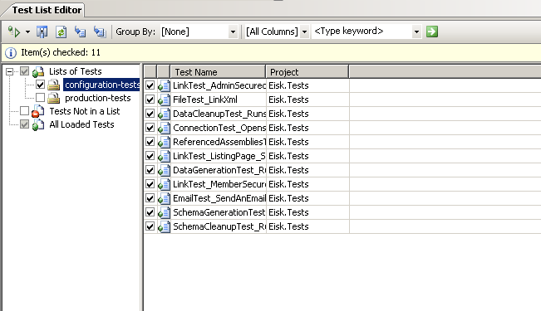
Select the “configuration tests” item from the “Test List Windows” and click on the “Run Checked Tests” command from the upper left corner of the “Test List Window”. The “Test Results” window as shown in the above picture will show the result of all configuration tests. There are two types of configuration test will be performed while running these tests.

Project Configuration
A set of unit tests that tests if the web link, email settings, reference assemblies are configured property.

Database Configuration
A set of unit tests that tests if the database connection string, test data generation/cleanup scripts are available.

Production Tests
Besides the configuration test, the test project included with this starter kit contains a verity of tests that are available in VSTS 2008, such as Web Test, Unit Test, Load Test, Database Unit Test etc.
You can run all the production tests the same way as you did for configuration test by running the “production-tests” as listed in the “Test List Editor”.
Here is the list of production test main categories.

Data Access Layer Testing
Contains all of the data access layer related tests, which are basically VSTS Unit Tests written in C#.

Implementation Artifact
<Extraction directory>\tests\unit-tests\data-access-layer

Lazy Data Access Layer Testing
Well you may not always like to do the repetitive tasks to write unit test for all of your data access layer components, especially for the generated codes. However if we could do it with a very minimal effort then that could be really great to gain our confidence with respect to our data access layer. We can easily do it by implementing a simple test class that implements exclusive use of .NET Reflection. You can get the full idea how to do it by checking the LazyUnitTestBase class.

Implementation Artifact
<Extraction directory>\tests\unit-tests\data-access-layer

Database Unit Testing
Database Unit Testing is a nice addition in testing world available in VSTS 2008. Now you can unit test you SQL Server T-SQL code using this VSTS 2008 feature.

Implementation Artifact
<Extraction directory>\tests\database-unit-tests

Acceptance Testing for CRUD
The webs test provided in the test project test CRUD functionality as recorded via the VSTS recorder.

Implementation Artifact
<Extraction directory>\tests\web-tests\

Load Testing
The load test utilizes the web tests available in the test project to measure the site performance.

Implementation Artifact
<Extraction directory>\tests\load-tests\

Helper Classes
Helper classes are great to reduce codes in the test cases!

Implementation Artifact
<Extraction directory>\tests\helper\

Automated Setup
The TestAssemblySetup class contains two methods named BasicSetup and BasicCleanup having two attributes AssemblyInitialize and AssemblyCleanup .NET attribute enables us to perform automated setup operations, such as test data generation etc.

Database Schema and Data Generator
The TestHelperRoot.TestDataHelper class contains the utility methods to create or clean database schema, data etc.

COM+ Helper
While doing test, you may want to generate the test schema and data prior to the test case execution, let the test cases modify as required by them and finally turn the database back as it was before the test. This is an excellent process to perform test operations on the live database without having any impact due to test executions. This can be possible with very tiny effort by using COM+ Transaction, which has been implementing in TestHelperRoot.TransactionHelper class.

Factory Method
Having a Factory Method for data entity greatly helps of isolate the instance creation of entity classes that are required to be created in the test cases and thus managing the test cases becomes very easy. The TestHelperRoot.EntityFactory provides these helpful stuffs.

Web Request Helper
The TestHelperRoot.WebRequestHelper class provides a useful technique to access the pages programmatically that requires authentication.

History
Second release: 17-April-2009
First release: 10-April-2008

License
You are free to copy, distribute and display this book. However please include my name “Mohammad Ashraful Alam” while referring any content of this book.

Disclaimer
The content provided here is “As Is” and no warranty is provided with respect to accuracy, error or misprints. Besides, although the model is based on Microsoft .NET Framework related application, however none of content here is contributed by Microsoft Corporation.

Feedback
Please have your valuable inputs to be sent to the following email to make it better.
Mohammad Ashraful Alam – ashraf@mvps.org

About the Author
Mohammad Ashraful Alam is a Software Engineer, who is dedicated to Microsoft .NET based development. This Bangladeshi national is involved with project management and development of several US based software projects from his country. Already he has managed and developed 25 software projects, which are being used by several users of different countries, such as USA, Canada, Australia, and Bangladesh. While developing and managing a team, he contains and maintains a set of well defined engineering practices developed by him and other online developer community. Beside software development, he has also written several technical articles and research papers published by IEEE Computer Society and many other worlds recognized publishers.
Before becoming engaged with software development, he was involved with Bengali literature and several Bengali news papers as freelance journalist and published around 150 articles, essays and short stories.
Due to his willingness to give effort to improve and share better software development practices, Ashraf has awarded as “Most Valuable Professional” (MVP) in ASP.NET category by Microsoft for multiple times, since 2007.
When not engaged with technical stuffs, he likes to pass time with his friends and family members, listening music or watches TV.
Check his blog here: http://geekswithblogs.net/joycsharp

